第十一章：使用对象-关系映射持久化数据

整合Hibernate框架
为方便学习，整合了一个Demo，Maven下SpringMVC+Spring+Hibernate+Jpa，地址：
https://github.com/cairuojin/Demo-Spring-Jpa.git

新建Maven项目
配置POM如下：
<?xml version="1.0" encoding="UTF-8"?>
<project xmlns="http://maven.apache.org/POM/4.0.0"
xmlns:xsi="http://www.w3.org/2001/XMLSchema-instance"
xsi:schemaLocation="http://maven.apache.org/POM/4.0.0 http://maven.apache.org/xsd/maven-4.0.0.xsd">
<modelVersion>4.0.0</modelVersion>
<groupId>com.eugene</groupId>
<artifactId>demo-spring-jpa</artifactId>
<version>1.0-SNAPSHOT</version>
<packaging>war</packaging>
<properties>
<project.build.sourceEncoding>UTF-8</project.build.sourceEncoding>
<maven.compiler.source>1.8</maven.compiler.source>
<maven.compiler.target>1.8</maven.compiler.target>
<spring.version>5.1.6.RELEASE</spring.version>
</properties>
<dependencies>
<!-- Spring -->
<dependency>
<groupId>org.springframework</groupId>
<artifactId>spring-context</artifactId>
<version>${spring.version}</version>
</dependency>
<dependency>
<groupId>org.springframework</groupId>
<artifactId>spring-beans</artifactId>
<version>${spring.version}</version>
</dependency>
<dependency>
<groupId>org.springframework</groupId>
<artifactId>spring-webmvc</artifactId>
<version>${spring.version}</version>
</dependency>
<dependency>
<groupId>junit</groupId>
<artifactId>junit</artifactId>
<version>4.11</version>
<scope>test</scope>
</dependency>
<dependency>
<groupId>org.slf4j</groupId>
<artifactId>slf4j-log4j12</artifactId>
<version>1.8.0-alpha0</version>
<scope>test</scope>
</dependency>
<!-- JSP相关 -->
<dependency>
<groupId>jstl</groupId>
<artifactId>jstl</artifactId>
<version>1.2</version>
</dependency>
<dependency>
<groupId>javax.servlet</groupId>
<artifactId>servlet-api</artifactId>
<version>2.5</version>
<scope>provided</scope>
</dependency>
<dependency>
<groupId>javax.servlet</groupId>
<artifactId>jsp-api</artifactId>
<version>2.0</version>
<scope>provided</scope>
</dependency>
</dependencies>
<build>
<plugins>
<!-- 配置tomcat插件 -->
<plugin>
<groupId>org.apache.tomcat.maven</groupId>
<artifactId>tomcat7-maven-plugin</artifactId>
<configuration>
<port>8080</port>
<path>/</path>
</configuration>
</plugin>
<plugin>
<groupId>org.apache.maven.plugins</groupId>
<artifactId>maven-compiler-plugin</artifactId>
<configuration>
<source>1.8</source>
<target>1.8</target>
</configuration>
</plugin>
</plugins>
</build>
</project>

集成SpringMVC
Web.xml：
<?xml version="1.0" encoding="UTF-8"?>
<web-app xmlns="http://xmlns.jcp.org/xml/ns/javaee"
xmlns:xsi="http://www.w3.org/2001/XMLSchema-instance"
xsi:schemaLocation="http://xmlns.jcp.org/xml/ns/javaee http://xmlns.jcp.org/xml/ns/javaee/web-app_4_0.xsd"
version="4.0">
<!-- 编码过滤器 -->
<filter>
<filter-name>encodingFilter</filter-name>
<filter-class>org.springframework.web.filter.CharacterEncodingFilter</filter-class>
<init-param>
<param-name>encoding</param-name>
<param-value>UTF-8</param-value>
</init-param>
</filter>
<filter-mapping>
<filter-name>encodingFilter</filter-name>
<url-pattern>/*</url-pattern>
</filter-mapping>
<!-- Spring MVC -->
<servlet>
<servlet-name>SpringMVC</servlet-name>
<servlet-class>org.springframework.web.servlet.DispatcherServlet</servlet-class>
<!-- 配置springMVC需要加载的配置文件-->
<init-param>
<param-name>contextConfigLocation</param-name>
<param-value>classpath:spring*.xml</param-value>
</init-param>
<load-on-startup>1</load-on-startup>
<async-supported>true</async-supported>
</servlet>
<servlet-mapping>
<servlet-name>SpringMVC</servlet-name>
<!-- 匹配所有请求，此处也可以配置成 *.do 形式 -->
<url-pattern>/</url-pattern>
</servlet-mapping>
</web-app>

SpringMVC配置：
<beans xmlns="http://www.springframework.org/schema/beans"
xmlns:xsi="http://www.w3.org/2001/XMLSchema-instance"
xmlns:context="http://www.springframework.org/schema/context"
xmlns:mvc="http://www.springframework.org/schema/mvc"
xsi:schemaLocation="http://www.springframework.org/schema/beans
http://www.springframework.org/schema/beans/spring-beans.xsd
http://www.springframework.org/schema/mvc
http://www.springframework.org/schema/mvc/spring-mvc-3.0.xsd">
<!-- 扫描web相关的bean -->
<context:component-scan base-package="com.eugene.springJpa.controller"/>
<!-- 开启SpringMVC注解模式 -->
<mvc:annotation-driven/>
<!-- 配置jsp 显示ViewResolver -->
<bean class="org.springframework.web.servlet.view.InternalResourceViewResolver">
<property name="prefix" value="/WEB-INF/jsp/" />
<property name="suffix" value=".jsp" />
</bean>
<!-- 配置静态资源映射 -->
<!-- 指定/WEB-INF/js /WEB-INF/css/ 下的所有的静态资源包括子目录下的静态资源 都不被拦截-->
<mvc:resources location="WEB-INF/js/" mapping="/js/**"/>
<mvc:resources location="WEB-INF/css/" mapping="/css/**"/>
</beans>

此时即已经集成好SpringMVC，开始集成Hibernate和JPA。
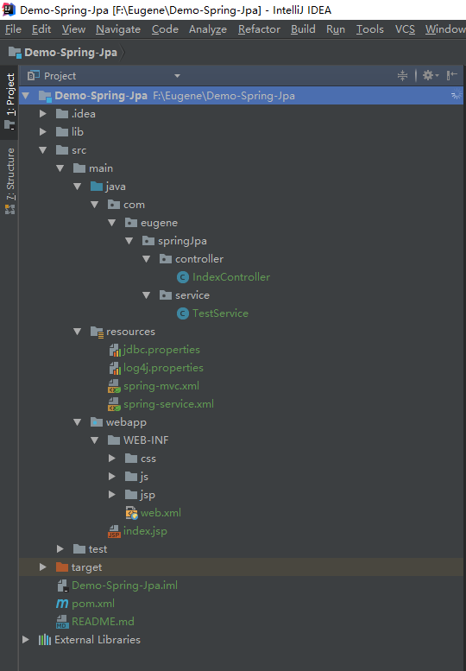

集成Hibernate + JPA
继续在POM中添加相关依赖如下：
<!-- spring data jpa 数据库持久层 -->
<dependency>
<groupId>org.springframework.data</groupId>
<artifactId>spring-data-jpa</artifactId>
<version>1.10.4.RELEASE</version>
</dependency>
<!-- hibernate 框架 -->
<dependency>
<groupId>org.hibernate</groupId>
<artifactId>hibernate-core</artifactId>
<version>${hibernate.version}</version>
</dependency>
<dependency>
<groupId>org.hibernate</groupId>
<artifactId>hibernate-entitymanager</artifactId>
<version>${hibernate.version}</version>
</dependency>
<!-- Mysql-connect -->
<dependency>
<groupId>mysql</groupId>
<artifactId>mysql-connector-java</artifactId>
<version>5.1.32</version>
</dependency>

添加jdbc.properties
#数据库驱动
datasource.driver=com.mysql.jdbc.Driver
#数据库连接
datasource.url=jdbc:mysql://119.29.203.133:3306/engenetest?useSSL=false
#用户名
datasource.username=cairuojin
#用户密码
datasource.password=

开始配置Spring集成Hibernate和Jpa的配置，添加spring-dao.xml配置
<beans xmlns="http://www.springframework.org/schema/beans"
xmlns:context="http://www.springframework.org/schema/context"
xmlns:jpa="http://www.springframework.org/schema/data/jpa"
xmlns:xsi="http://www.w3.org/2001/XMLSchema-instance" xmlns:tx="http://www.springframework.org/schema/tx"
xsi:schemaLocation="http://www.springframework.org/schema/beans http://www.springframework.org/schema/beans/spring-beans-4.2.xsd
http://www.springframework.org/schema/context http://www.springframework.org/schema/context/spring-context-4.2.xsd
http://www.springframework.org/schema/data/jpa http://www.springframework.org/schema/data/jpa/spring-jpa-1.3.xsd
http://www.springframework.org/schema/tx http://www.springframework.org/schema/tx/spring-tx.xsd">
<!-- 加载数据库配置 -->
<context:property-placeholder location="classpath:jdbc.properties"/>
<!-- 配置数据库连接 -->
<!-- 数据源配置, 使用Tomcat JDBC连接池 -->
<bean id="dataSource" class="org.springframework.jdbc.datasource.DriverManagerDataSource">
<property name="driverClassName" value="${datasource.driver}" />
<property name="url" value="${datasource.url}" />
<property name="username" value="${datasource.username}" />
<property name="password" value="${datasource.password}" />
</bean>
<!-- spring整合JPA -->
<!-- Jpa Entity Manager 配置 -->
<bean id="entityManagerFactory" class="org.springframework.orm.jpa.LocalContainerEntityManagerFactoryBean">
<property name="dataSource" ref="dataSource"/>
<property name="jpaVendorAdapter" ref="hibernateJpaVendorAdapter"/>
<property name="packagesToScan" value="com.eugene.springJpa.domain"/>
<property name="jpaProperties">
<props>
<!-- 命名规则 My_NAME->MyName
<prop key="hibernate.ejb.naming_strategy">org.hibernate.cfg.ImprovedNamingStrategy</prop> -->
<prop key="hibernate.show_sql">true</prop>
<prop key="hibernate.format_sql">false</prop>
</props>
</property>
</bean>
<bean id="hibernateJpaVendorAdapter" class="org.springframework.orm.jpa.vendor.HibernateJpaVendorAdapter">
<!-- 自动建表 -->
<property name="generateDdl" value="true" />
<property name="database" value="MYSQL" />
<property name="databasePlatform" value="org.hibernate.dialect.MySQL5Dialect" />
<property name="showSql" value="true" />
</bean>
<!-- 配置事务管理器 -->
<bean id="transactionManager" class="org.springframework.orm.jpa.JpaTransactionManager">
<property name="entityManagerFactory" ref="entityManagerFactory" />
</bean>
<!-- 开启事务注解 -->
<tx:annotation-driven transaction-manager="transactionManager" />
<!--指定Spring Data JPA要进行扫描的包,该包中的类框架会自动为其创建代理-->
<jpa:repositories base-package="com.eugene.springJpa.dao" />
</beans>

进行测试
添加POJO类和dao类，使用页面尝试增删改查操作
package com.eugene.springJpa.domain;
import javax.persistence.*;
@Entity
@Table(name = "book")
public class Book {
@Id
@GeneratedValue
@Column(name = "id")
private Integer id;
@Column(name = "name")
private String name;
@Column(name = "writer")
private String writer;
public Integer getId() {
return id;
}
public void setId(Integer id) {
this.id = id;
}
public String getName() {
return name;
}
public void setName(String name) {
this.name = name;
}
public String getWriter() {
return writer;
}
public void setWriter(String writer) {
this.writer = writer;
}
}

package com.eugene.springJpa.dao;
import com.eugene.springJpa.domain.Book;
import org.springframework.data.jpa.repository.JpaRepository;
public interface BookDao extends JpaRepository<Book, String> {
}

Spring的数据访问哲学

